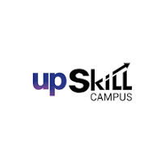  

Industrial Internship Report on

”Data Science and Machine Learning Project”

Prepared by

Zaheer Khan

Student I.D:ABS2201016

College Name: Ascencia Business School

Executive Summary

In this internship project, I learned about data science and machine learning and how to implement it using Python. During this training, we first teach you the basics of the Python language, how to use it, and how easy it is to use it in everyday projects. After being introduced to Python training, I learned how to use various Python libraries to implement data science and machine learning, and take my projects far with just a few lines of code. Data science is a field that tries to implement AI using machine learning and deep learning, which is part of artificial intelligence. This is how robots and the various tools we use are designed, allowing machines to think for themselves and make their own decisions. Many machine learning problems are designed to reduce some missing features in a set of training models. Throughout my experience, I have acquired several useful Python programming skills. Enable statistical data analysis using Python libraries such as Pandas. Use symbols and bar graphs to illustrate your point. Professional presentation of statistical data analysis.

Preface

Summary:

I recently completed a 5-month winter internship in data science and machine learning from Upskill campus for my college. Like everyone else, my training and other courses are always virtual. Although I didn't have any in-person coaching experience, I still feel like I was able to learn work ethic, time management, and communication skills. I worked and learned about data science, machine learning, Python, statistical probability through explanations and reference books. I also participated in quizzes and understood the topics as well as concepts and concepts.

Career Development of relevant Internship:

Internships offer students and fresher’s the opportunity to gain hands-on experience in their field and valuable skills for future employment. This is a unique opportunity to bridge the gap between academic learning and international application, allowing students to gain knowledge and skills that cannot be learned in the classroom.

There are several reasons why internships can be beneficial for career advancement: Obtain practical experience, develop professional skills, build industry connections, and gain recognition from employers.

Brief about the work/Project:

Understanding the Business Problem  
Before completing the project, several questions were asked to fully understand the actual business problem. If a data source is available or the end goal of the project  
  
Collecting data sources  
We start collecting data. It comes from databases and partners. Gathering the right data sources is like taking data from many websites to process the data.  
  
Data Processing  
We have started collecting data sources from databases and partners. Gathering the right data sources is like taking data from many websites to process the data.  
  
Model Evaluation  
Building models in the past has been a big learning curve for me, still learning through MOOCs and textbooks. Fortunately, Scikit-Learn and Keras are useful because they make it easy to learn how to create prototypes and quickly implement Python.

Opportunities provided by UTC:

UTC offers training opportunities that provide first-hand experience, professional opportunities and personal growth. Competition becomes more intense when applying for jobs. As an intern, you will gain the skills needed to present your career.

How program was planned?

This program is designed to engage students in the work of advanced data analytics and data science, as well machine learning applications within the realms of science and engineering. Candidates are expected to possess advanced analytical skills and techniques, which are based on their work experience and academic knowledge.

Learnings and Overall experience

Data science training gives you exposure to real-world data topics while providing you with the skills you need to succeed in today's data-driven world. This valuable hands-on experience allows you to apply the knowledge you learn in the classroom to solve complex problems facing your organization.

The internship was my first exposure to the professional world and really helped me develop my personal skills. I developed a positive attitude, ability to take responsibility and a sense of creativity, resourcefulness, openness and sensitivity to change. This instilled in me the desire to learn for a long time.

I would like to thank Upskill and its team for giving me the opportunity to undertake a training program to gain experience and knowledge in the field.

My advice to my juniors and peers is to understand your chosen subject of any field and focus on it and work accordingly to it.

Section 2:

IoT Uniconverge Technologies

Introduction

Uniconverge Technologies Private Limited, a private holding company, was registered on 28 MayGautam Buddha Nagar, Uttar Pradesh is the location of a private limited company. Both are registered as companies. The authorized share capital is INR 1.The paid up capital amounts to INR 1 and the total amount of 100 lac.

The operating income of Uniconverge Technologies Private Limited was between INR 1 cr and INI 100 cr for the year ending March 31, EBITDA decreased by -5,743.22% compared to the previous year. At the same time, the net result of the book decreased by -175.84%.

IoT Academy is a NCR company that was established by seasoned IT professionals with extensive experience in various industries who have worked at multiple companies for many years.A fast-paced enterprise that delivers top-notch and budget-friendly courses for both students and professors. They specialize in training programs and skill development programs to help you in your career.

IOT Platform

The industry wants to use the next technologies to transform itself digitally. All jobs and processes must be converted from traditional manual to digital. This can increase productivity and reduce energy consumption or material waste.

Businesses generally face the problem of unplanned downtime, which can cost people, machinery, property, time and reputation. Downtime can be caused by various electrical and mechanical failures in machines.

Currently, the industry has a real-time monitoring solution called condition monitoring. He is in sensitive care. This means that even if a component breaks down, the maintenance team will fix it, but the production process will still be interrupted for some time.

IOT Academy

The best programming courses online are available in Noida through IoT Academy. For students who are pursuing a degree and want to maximize their time, online education is an essential aspect. In today's competitive world, it is not enough to limit the time students spend in college. Students need to step out of their comfort zone and experience the working environment of the IT industry. IoT Academy offers excellent online training courses and live programs that encourage students to develop industry-relevant skills. We help students across India to implement their education through our online education programs. The program is designed to help students enter the industry. By working on a unique project and putting all of their thoughts and ideas into it, students will understand how the concept applies to the real world. We provide students with life projects that they can undertake independently under expert guidance. The technology sector is growing rapidly. Companies are not only looking for qualified people, but people with great knowledge and skills. It is important that students are aware of the need to stay ahead in the industry. By participating in IoT Academy's online training programs, students can create a competitive advantage for themselves. Our online training programs help students get into their favorite organizations easily. Our training prepares students for work and builds their confidence as they enter the workforce. Gather your energy to experience effective and challenging online education with us.

The purpose of this training program is

i) To gain practical experience in the sector.

ii) Solving real-world problems.

iii) Employment prospects have improved.

iv) Improved understanding of our field and its applications.

v) I want to grow, including better communication and problem solving.

Reference:

1) Intel NUC Gateway

2) Scalable Processing

3) Open Source Technology

Glossary:

|  |  |
| --- | --- |
| Terms | Acronym |
| Access Control | The process of managing and controlling access to a system or network, typically through user authentication, authorization, and permissions. |
| Application Security | It refers to a set of measures and practices used to protect computer applications from cyber-attacks and data leaks. |
| Cloud Security | It refers to a set of measures and practices used to protect data, applications and managed infrastructure in a cloud environment. |
| Block chain | It is a shared and distributed ledger technology that provides a secure and transparent way to store and exchange information. |
| Cybersecurity | Set of measures and procedures used to protect computer systems, networks and data from cyber-attacks, theft and damage. |

3. Problem Statement:

Problem statements are brief summaries of the problem at hand and its corresponding solution. It defines the scope of the project and sets the direction for the analysis. A problem statement that is clearly stated will enable data scientists to concentrate on the pertinent data, select appropriate methods, and evaluate the project's success.

A problem statement is essential for any data science project because it outlines the objectives, scope, and direction, while also providing guidance on selecting appropriate methods and tools to analyze.

It sets the direction for the analysis, guides the selection of appropriate methods and tools, and helps to measure the success of the project. By following the steps outlined in this tutorial and using the examples provided, data scientists can define a clear problem statement that leads to a successful data science project.

As a machine learning and data science Intern, my role is to work with and understand services to build linear regression models in Python and analytical methods for statistical and probabilistic data.

Understand the data.

Convert literal variables to numeric variables.

Apply linear regression to predict CTC.

Evaluate the results of the analysis.

4. Existing and Proposed solution:

Research limitations are elements of methodology and study design that affect the interpretation of research results. Limitations clearly describe the flaws and shortcomings of the study. Study limitations exist due to limitations in study design, methods, materials, etc., and may affect the results of the study. However, researchers are often reluctant to discuss the limitations of their research in their articles because they believe that mentioning the limitations will reduce the value of the research in the eyes of readers and reviewers.

Limitations address potential weaknesses of the research, but writing about them at the end of the paper can greatly strengthen the research by identifying problems before other researchers or reviewers discover them.

Looking for sampling and selection issues

Small sample size for statistical measurement

Methods/instruments/methods for data collection

The objective solution I use is to define learning limitations, which refers to learning limitations. Now it's time to explain what the limitations are and how they affect learning. For example, when conducting quantitative research, lack of sample size is an important issue that needs to be addressed. On the other hand, when conducting qualitative research, the inability to generalize the results is an issue worth mentioning.

The value that data science adds to a business by using data to develop solutions and optimize daily operations. Data science can be used to make more informed business decisions based on statistics, candidate engagement and a data-driven approach.

5. Proposed Design/Model

5.1 High Level of Diagram

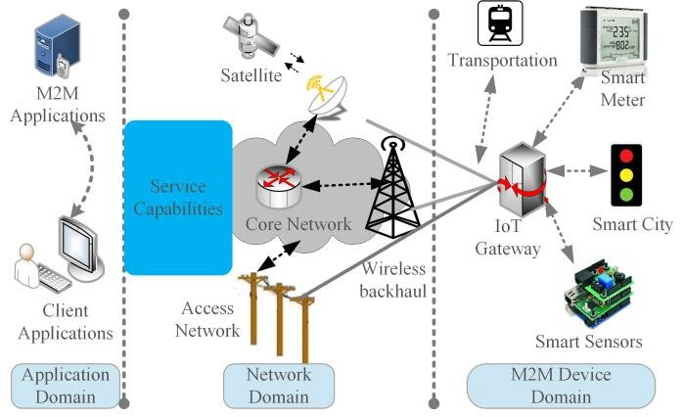

5.2 Low level of Diagram

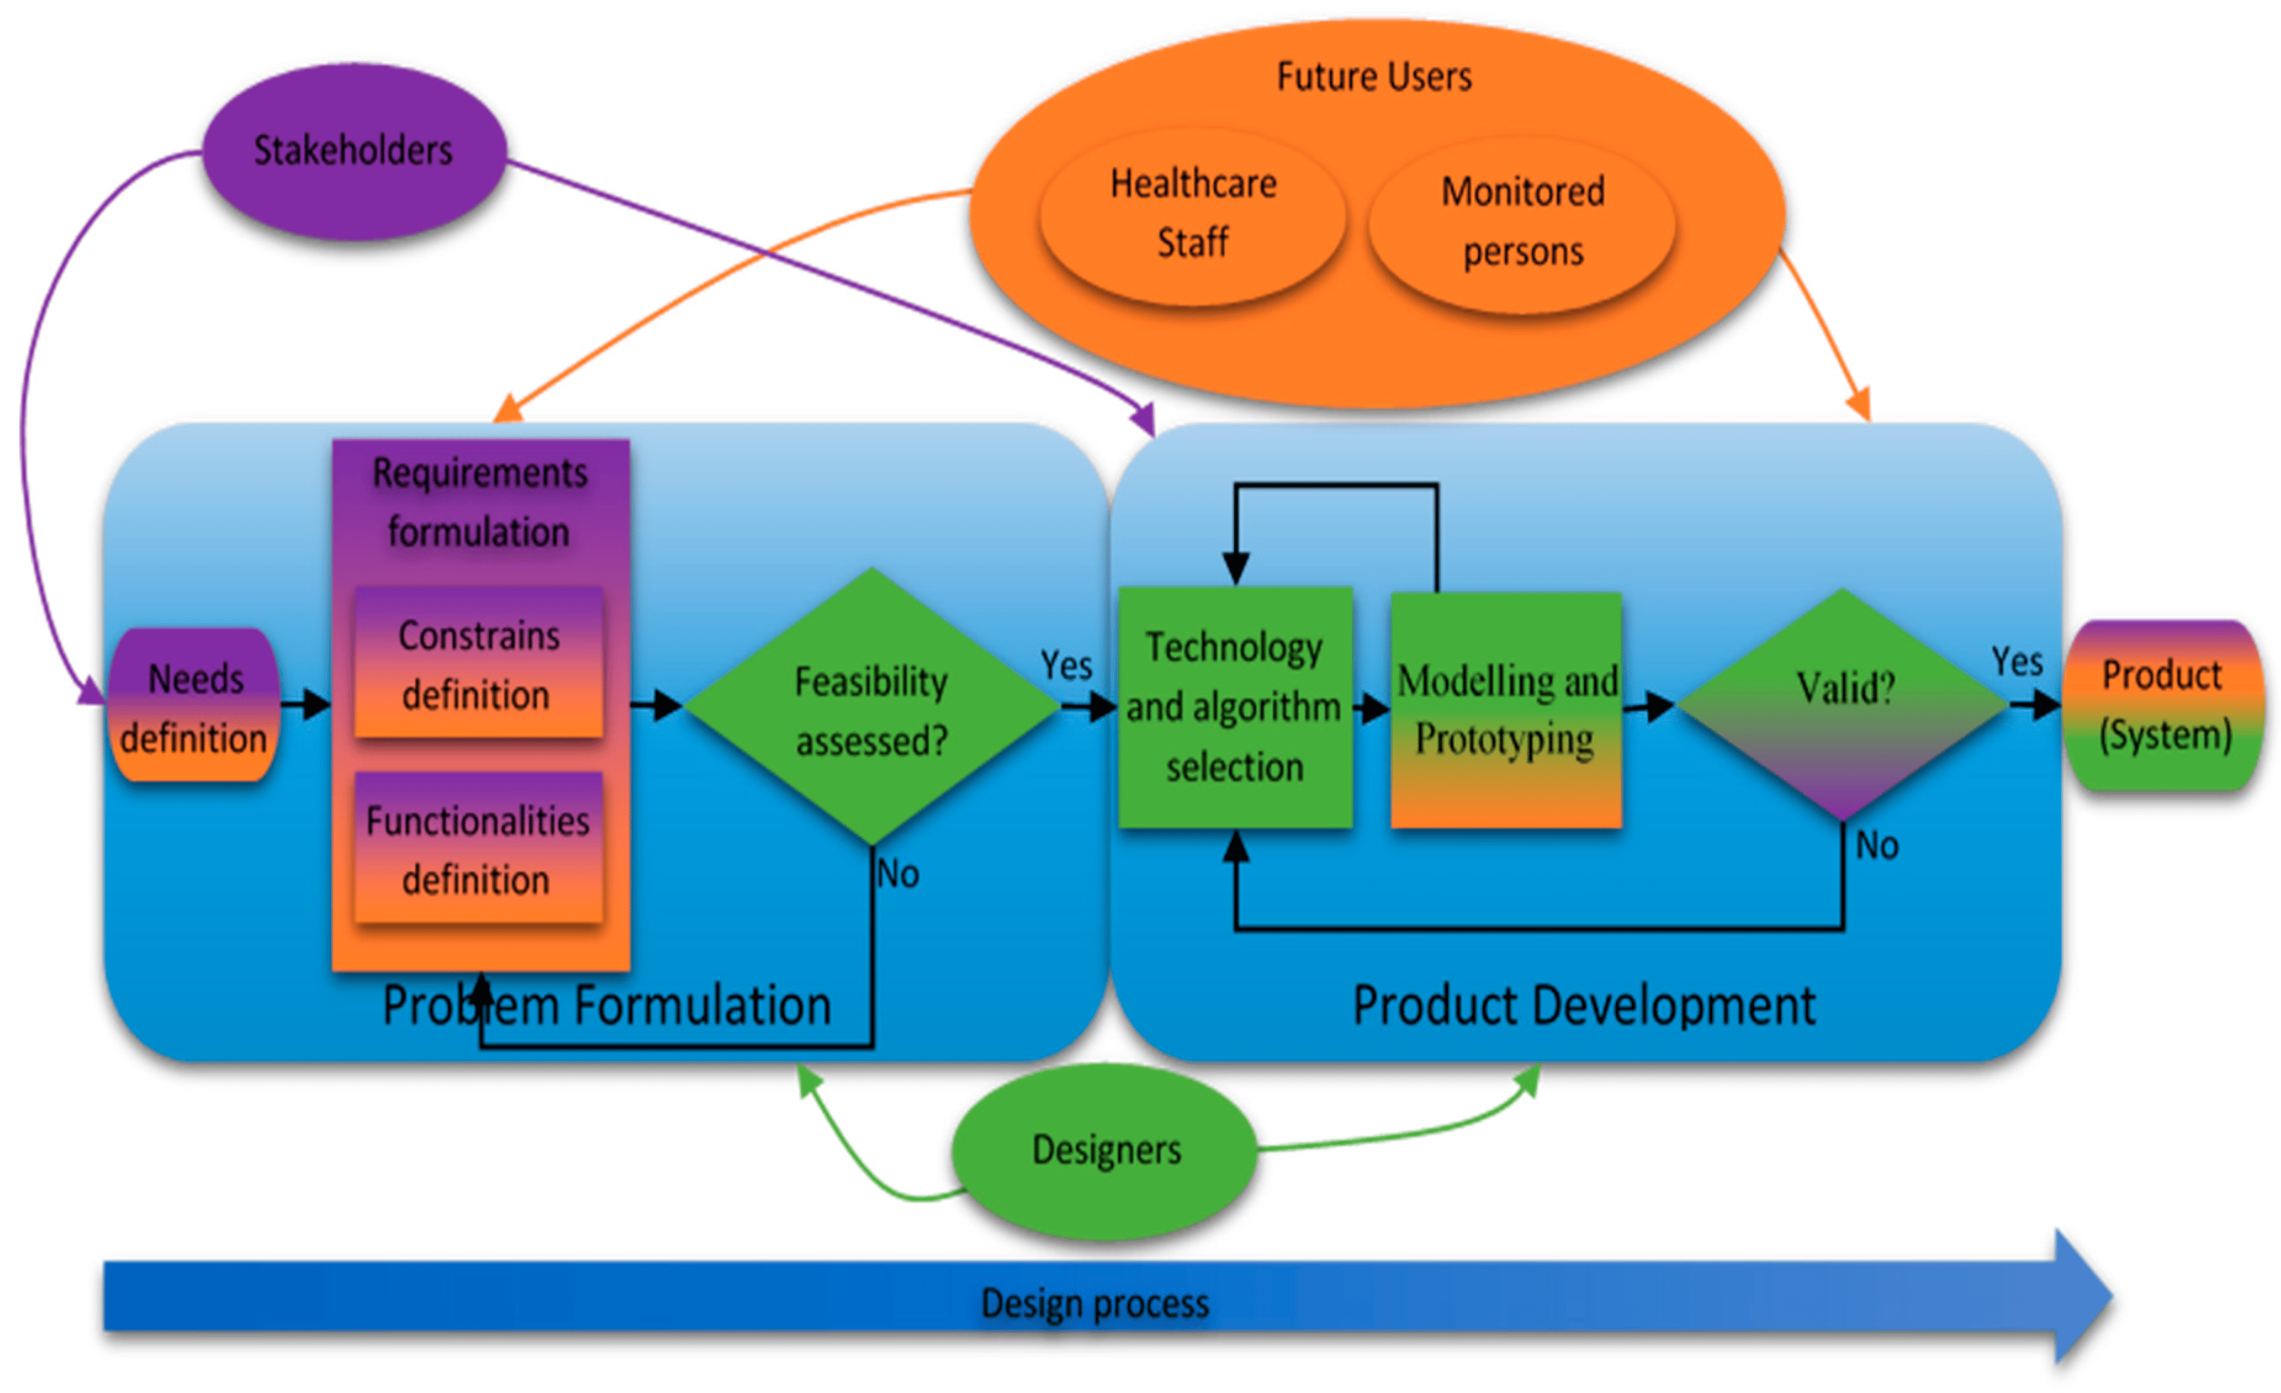

6. Performance Test

Performance testing is a non-functional computing testing technique that determines how stable, fast, scalable, and responsive an application is under a given workload. This is a key step in ensuring software quality, but it is often overlooked and begins after functional testing is complete and, in most cases, after the code is ready to be deployed.

Performance test objectives are to evaluate application output, processing speed, data transfer speed, network bandwidth usage, most common users, memory usage, efficiency performance and command response time.

When designing IoT applications, the limitations of certain hardware components may impact the overall performance and functionality. These restrictions may vary depending on the specific equipment used, but there are some general restrictions that manufacturers should be aware of.

Low processing power:

Many IoT devices have low processing power compared to older computers. This affects the device's ability to perform complex calculations and process large amounts of data. Developers should optimize their code to optimize processing and avoid hardware overload.

Limited Memory:

IoT devices have limited memory for data storage and processing. This can be difficult when working with large datasets or complex algorithms. Developers must carefully manage memory usage and optimize data storage for optimal performance.

Poor connectivity:

IoT devices may have limited network connectivity. Bandwidth may be limited and may affect the speed of data transfer to your device. In addition, IoT devices may experience interconnection, so developers must properly manage network components.

Power limitations:

Many IoT devices run on batteries and have limited power sources. This means that developers must carefully consider power consumption when designing their applications. Optimizing power usage will extend battery life and ensure your devices perform optimally.

Cost Considerations:

IoT devices are designed to be cost-effective, so developers must work within cost constraints when choosing hardware components. This can limit the range of available hardware options and force developers to prioritize some features over others.

In general, when developing IoT applications, it is important to understand the hardware limitations that exist. By carefully considering these limitations and optimizing code and design accordingly, developers can create effective and successful IoT applications.

7. My Learnings:

I started looking for summer internship opportunities a few months ago, hoping to find a position that would allow me to gain experience in data science, a field that has captured my interest in the past year. While working at an IoT startup last summer that integrated multiple data sources, analytics, and machine learning, I realized that there are many skills companies look for in data scientists.

The following is a summary of my experiences over the past few months interviewing for analyst positions at companies of various sizes across the country. Although the sample size is small, I hope it is indicative of the hiring process for this position based on my very varied experience interviewing for analytics jobs. I would like to know about this so that this guide can be more visible and useful to others.

The most common job titles for analytics jobs in technology companies are product analyst, data scientist, data scientist, or data analyst. When big companies and big data organizations give analytics the title of data scientist, they often distinguish between a data analytics scientist, a data-driven machine learning scientist, and an ideological scientist.

Data scientists ask questions that can be answered by data and improve business processes, decide what data to collect to answer those questions, build models/analyze data to answer questions, and watch events to drive value. You have a deep understanding of the mathematics behind various machine learning models and the programming skills to implement these models and make inferences from the data being collected.

Data science internship allows undergraduate students interested in data science to learn more about the field and gain valuable experience in all aspects of data science, from asking the right questions to deciding what data to collect, analyze the data and generate results. an important part. .

Knowing the different models and knowing which one is right for a given problem will help you during the interview, and if you don't have much work experience, it will help and assist in doing side projects.

8. Future work scope:

The work must be the primary asset and must have a primary sponsor. It should be at the top of the pyramid, one focus below the company's other priorities.

The way it works in most organizations has evolved through a combination of best practices and practices that have been established over many years. This is due to the limitations of the technology used in the workforce. But in the last three years, conventions have been broken, many good practices have been abandoned, and many new ideas about the relationship between work and technology have emerged. Companies should abandon this new project. Failure to do so would negate the scope and speed of change that has taken place over the past three years.

Time to confirm EX. Each EX strategy has four pillars:

i) Company goals, values ​​and culture,

ii) Compensation and benefits,

iii) Professional development and promotion,

iv) Organizational culture. Create an integrated, technology-driven experience through these elements.

Studies show that for a third of workers, the only thing that sets them apart from their work elsewhere is the quality of their daily technology and work experience. It's not about more money, a promotion or new responsibilities; it's about a better experience doing your day job.

Studies show that the quality of the day-to-day technical experience is the second most influential driver, after opportunities for career growth and advancement.

Learning is a waste of time. You will listen to the lesson, fill in the information and take a short quiz at the end to sharpen your memory for a while. There is no opportunity to use that information. A check mark in the box will keep it in the right place, and a manager or department head can point to it and say the number has gone up.

It's mostly smoke and mirrors. Developing your skills through learning can help you become more productive, more productive, stronger, more valuable, and more productive to have more options.

Early in my career, I struggled to provide training on the most effective methods supported by managers. We ended up offering two-day training for the whole department, which is still the highest level. The training I have had throughout my career has given me the skills I need to work.